Read about Tony the teacher and answer the questions. Přečti si o panu učiteli Tonym a odpověz (jednoduše – jedním slovem, nepiš celé věty)
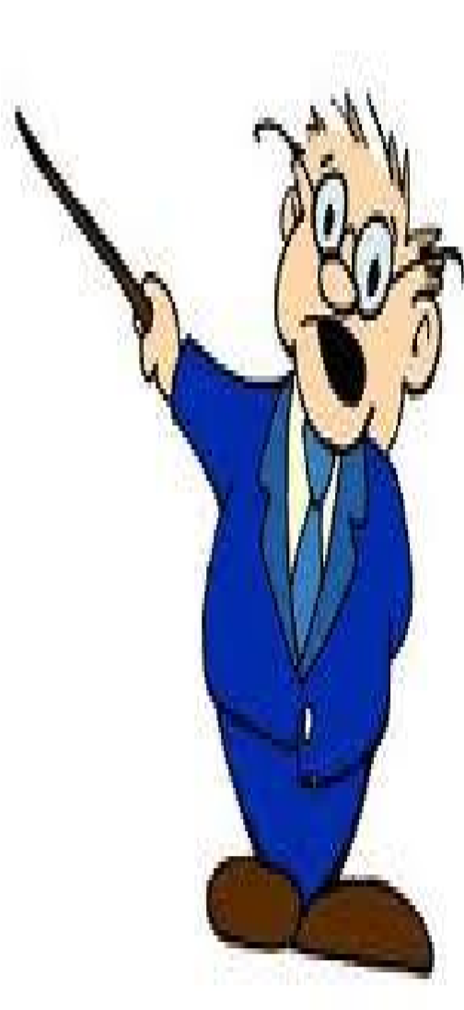
This is Tony. He’s a teacher. He’s old and a little fat. He works at the school. He teaches English.

Every day he gets up at half past six in the morning. He takes a shower and puts on a shirt and tie. Then he eats breakfast at seven o’clock. At quarter past seven, he rides his motorcycle to school.
Tony starts work at eight o’clock. He cleans the classroom. Then, he talks with his students’ parents. He starts teaching at nine o’clock. At twelve o’clock, he has lunch. He teaches again in the afternoon. He goes home at half past four.
In the evening, he feeds his goldfish and he watches TV. He has dinner at half past six. Then he corrects students’ homework. At ten o’clock, he goes to bed.

- What’s his name?
- Where does he work?
- Is he thin (hubený)?
- Does he get up at five o’clock?
- Does he eat breakfast at seven o’clock?
- Does he clean the classroom?
- Does he watch TV in school?
- At what time does he have lunch?
- Has he got any pets?
- At what time does he have dinner?

