***Lies und schreib auf. Čti a napiš.***

C:\Users\Kantor\AppData\Local\Microsoft\Windows\Temporary Internet Files\Content.IE5\Z9X2RNJ4\MC900438153[1].wmfC:\Users\Kantor\AppData\Local\Microsoft\Windows\Temporary Internet Files\Content.IE5\G9P1IMCH\MC900237555[1].wmf

C:\Users\Kantor\AppData\Local\Microsoft\Windows\Temporary Internet Files\Content.IE5\G9P1IMCH\MC900355879[1].wmf

wir

sie

ich

___________ ___________ ____________

C:\Users\Kantor\AppData\Local\Microsoft\Windows\Temporary Internet Files\Content.IE5\Q5CQEYX3\MC900397478[1].wmfC:\Users\Kantor\AppData\Local\Microsoft\Windows\Temporary Internet Files\Content.IE5\Q5CQEYX3\MC900344825[1].wmfC:\Users\Kantor\AppData\Local\Microsoft\Windows\Temporary Internet Files\Content.IE5\2FA27MQ1\MC900232728[1].wmf

du

Tom

Nina

___________ ____________ ____________

C:\Users\Kantor\AppData\Local\Microsoft\Windows\Temporary Internet Files\Content.IE5\Z9X2RNJ4\MC900351219[1].wmf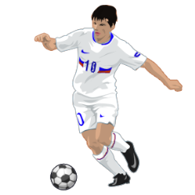

Paul und Inge

ihr

___________ _____________________

C:\Users\Kantor\AppData\Local\Microsoft\Windows\Temporary Internet Files\Content.IE5\Q5CQEYX3\MC900232180[1].wmf

C:\Users\Kantor\AppData\Local\Microsoft\Windows\Temporary Internet Files\Content.IE5\G9P1IMCH\MC900232934[1].wmf

wir

ich

du

___________ ____________ ____________